# Intro to Programming (Python)

Assignment 05

## Overview

In this activity, you will learn to work with for Lists and Dictionaries. Once again you will create your own scripts and document your knowledge. Your documents will be reviewed by your peers, so make your document and code look professional.

This assignment will include the following:

1. Watch the Module Videos.
2. Review the following web pages.
3. Watch the following videos.
4. Apply your knowledge.
5. Document your knowledge.
6. Submit your work to canvas.
7. Post your work on GitHub.
8. Perform a Peer Review.

## Step 1: Watch the Module Videos

Please watch the following Module videos:

* <https://www.youtube.com/playlist?list=PLfycUyp06LG9I4194n8OvgCbmEXQt3a8z> (opens to external site)

## Step 2: Review the following web pages

Please review the following web pages. These are shorter than the book and provide online resources you can use later.

* <http://en.wikibooks.org/wiki/Non-Programmer's_Tutorial_for_Python_2.6/Lists> (opens to external site)
* <http://www.bogotobogo.com/python/python_dictionaries_tuples.php>(opens to external site)
* <http://www.afterhoursprogramming.com/tutorial/Python/Reading-Files/> (opens to external site)

(Remember these additional links are to give you a different opinion / viewpoint of the material we are covering. You only need to review the web pages to see what is out there as a resource. You do not need to read them thoroughly. The idea is to expose you to many ways of looking at these topics and provide you will links to sites you can use in the future.)

## Step 3: Watch the support videos

Please watch this video. It will explain things a bit differently, which helps with learning!

* Reading from a text file: <https://youtu.be/m0o0CkYsDzI> (opens to external site)

## Step 4: Apply your knowledge

Now that you have reviewed the websites and videos, you will **create** a new script that manages a "ToDo list."

This project is like to the last one, but this time The ToDo file will contain two columns of data (Task, Priority) which you store in a Python *dictionary*. Each Dictionary will represent one row of data and these rows of data are added to a Python List to create a table of data.

1. **Create** a text file called Todo.txt using the following data:

Clean House,low

Pay Bills,high

1. When the program starts, **load** each **row** of data from the ToDo.txt text file **into** a Python **d*ictionary***. (The data will be stored like a row in a table.)

**Tip**: You can use a for loop to read a single line of text from the file and then place the data into a new dictionary object.

1. After you get the data in a Python dictionary, **Add** the new **dictionary** “row” **into** a Python **list** object (now the data will be managed as a table).
2. **Display** the contents of the List to the user.
3. Allow the user to **Add** or **Remove** tasks from the list using numbered choices. *Something* like this would work:

Menu of Options

1) Show current data

2) Add a new item.

3) Remove an existing item.

4) Save Data to File

5) Exit Program

1. **Save** the data from the table into the Todo.txt file when the program exits.

**Tip:** I have provided a starting template to help you organize your code and help with some of the coding. You can use it or create your own file from scratch, but you have a lot of work to do in this module so, you may want to take advantage of the help.

## Step 5: Document your knowledge

**Create** a simple document to outline the steps you took in performing this assignment. Make sure the document is in a Microsoft Word document format (.doc or .docx).

**NOTE**: *Make sure you put it in proper, college level, formatting!*

## Step 6: Submit your work

Now, **place** both your .doc or docx file and your python .py file into a folder called Assignment05 and zip the entire folder. Afterwards, **upload** the new zip file to the class assignment page.

## Step 7: Post your document

In this module, you need to **post** your zip file on a public GitHub so that others may review it.

1) Login to <https://github.com> (Make a new account if needed!)

2) Create a repository called ***IntroToProg-Python***

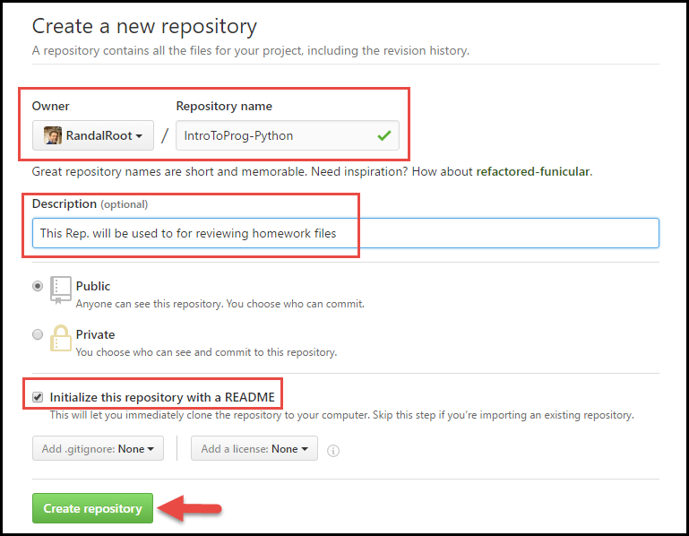

3) Upload your file to the repository

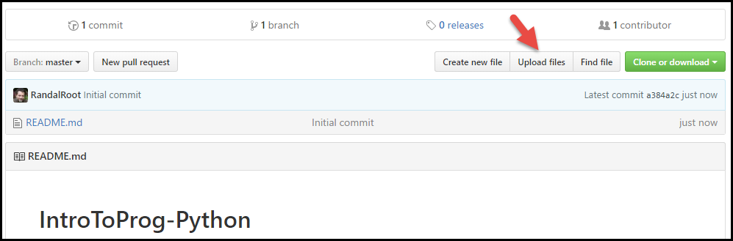

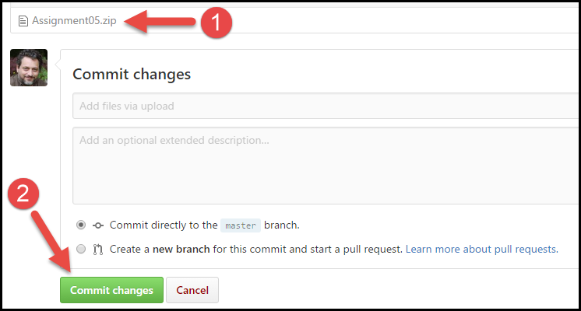

4) Copy the URL to your document

5) Submit the URL in Canvas

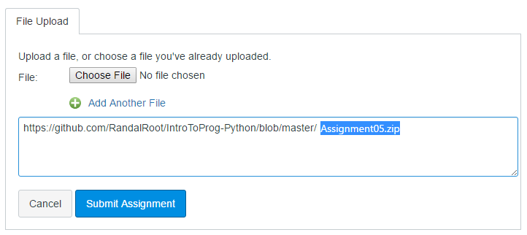

6) Post your link on the Canvas dicussion board so that others can see what you have created.

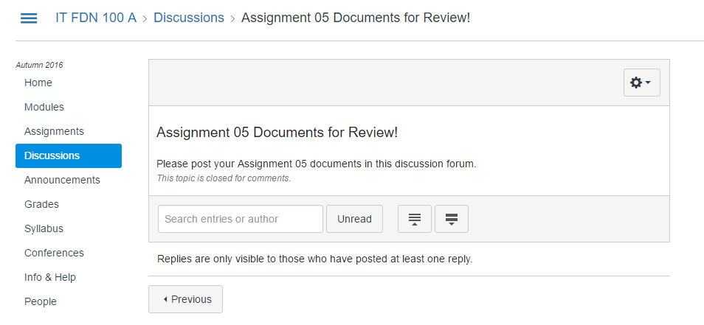

Here are some videos to help you learn what GitHub is and how it is used.

* What Is GitHub: <https://youtu.be/VUaBfYCmJls>
* How to use GitHub for Beginners: <https://youtu.be/E8TXME3bzNs>
* Setting up a GitHub Account: <https://youtu.be/Sk1_DU2ky48>

**Step 8: Perform a Peer Review**

You will be randonly assigned a review parter by Canvas after the assignment due date. Please **download and read** the assignment turned in by this student and **comments** on the discussion forum.

You do not need to go into a great details about someones work, but you do need to include:

* One thing that you liked about their paper
* One thing that could make their paper better

***You are done!***